**Intent enervates Content**

The inharmonious odyssey of futile pursuits;

That wrenches cognitive tranquility apart.

Blinded by the crave for ephemeral suits,

Galloping behind veiled, insubstantial art.

The wrath of King Dhritarashtra’s ambition,

Led to the encounter of gore and flame,

Laying ensanguined corpses in legion,

Turmoil and death tinged Aryavarta’s fame.

Do we perceive the angst fragment of past?

Do we ever sense Mother Earth’s pulse?

Ignorant of how long earnest peace lasts;

Unaware of fray, its dread and impulse.

Incessantly we battle beyond any reason,

Asphyxiating the pacifying dove under oppression.

-Aadityaamlan Panda

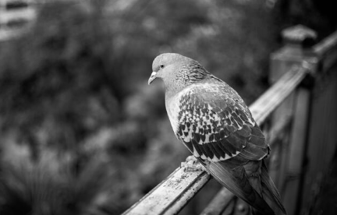

**Peace: The Heartbeat of World**

The inharmonious odyssey of futile pursuits;

That wrenches cognitive tranquility apart.

Blinded by the crave for ephemeral suits,

Galloping behind veiled, insubstantial art.

The wrath of King Dhritarashtra’s ambition,

Led to the encounter of gore and flame,

Laying ensanguined corpses in legion,

Turmoil and death tinged Aryavarta’s fame.

Do we perceive the angst fragment of past?

Do we ever sense Mother Earth’s pulse?

Ignorant of how earnest peace lasts;

Unaware of fray, its dread and impulse.

Incessantly we battle beyond any reason,

Asphyxiating the pacifying dove under oppression.

-Aadityaamlan Panda